**BEE BEAUTIFUL**

Bijaya Malla Thakuri

LC00017001156

TEXAS COLLEGE OF MANAGEMENT & IT



DEPARTMENT OF INFORMATION TECHNOLOGY

LINCOLN UNIVERSITY COLLEGE

September 27th, 2023

# DECLARATION

I hereby declare that the project work entitled “**Bee Beauty**” submitted to the Faculty of Science, Lincoln University College, Kathmandu is an original piece of work under the supervision of Mr. **Rohit Pandey** and is submitted in partial fulfillment of the requirements for the degree of Bachelor of Information Technology (BIT). This project work report has not been submitted to any other university or institution for the award of any degree.

………………………………… Mr. Rohit Pandey

Supervisor Department of IT

Texas College of management and IT Date: …………………...

# SUPERVISOR’S RECOMMENDATION

It is my pleasure to recommend that a report on “**Bee Beautiful**” has been prepared under my supervision by **Bijaya Malla Thakuri** in partial fulfillment of the requirement of the degree of Bachelor in Information Technology (BIT) . Her report is satisfactory to process for the future evaluation.

………………………………… Mr. Aashish Gautam

Supervisor Department of IT

Texas College of management and IT Date: …………………...

# **ACKNOWLEDGEMENT**

I would like to express my deepest appreciation to all those who provided me with the opportunity to complete this report. A special thank you goes to my project supervisor, Mr. **Rohit Pandey**, whose stimulating suggestions and encouragement helped me coordinate this project, particularly in writing this report. Furthermore, I would also like to acknowledge, with much appreciation, the crucial role of the staff of Texas College, who granted permission to use all the required equipment and materials necessary to complete the task. I am thankful and fortunate enough to receive constant support from my seniors and every teaching staff member of the BIT department, which greatly contributed to the successful completion of my project. My regards also extend to all the non-teaching staff of the BIT department for their timely support.

I am equally thankful to the esteemed faculty members, my dedicated supervisor, and the educators at [Texas College of Management and IT / Lincoln College University] for creating an environment conducive to learning and for imparting the essential knowledge and skills that laid a strong foundation for this project.

I would also like to take a moment to express my deepest gratitude to my friends and family for their unwavering support and encouragement. Their presence and motivation were instrumental during the project's various challenges and milestones.

With respect,

Bijaya Malla Thakuri

# **ABSTRACT**

In recent times, there has been a substantial surge in digital information volume and user numbers. Additionally, the frequency of data transactions on the internet has experienced a significant upswing. This has given rise to a potential issue known as information overload, which hampers the timely access to available internet data. As the user base continues to expand, data volume has also increased dramatically. Skin care products play a crucial role in maintaining and enhancing the health and appearance of the skin. This abstract provides an overview of key aspects related to skin care products, their importance, and their impact on skin health.

Skin is the body's largest organ and serves as a protective barrier against external environmental factors. As such, it requires proper care and attention to remain healthy and radiant. Skin care products encompass a wide range of formulations, including cleansers, moisturizers, sunscreens, serums, and specialized treatments, each designed to address specific skin concerns. Protection from the harmful effects of ultraviolet (UV) radiation is a crucial aspect of skin care. Sunscreen products shield the skin from UV rays, reducing the risk of sunburn, premature aging, and skin cancer. Daily sunscreen application is recommended to maintain healthy skin and prevent UV- induced damage.

Skin care products also target specific concerns, such as acne, aging, hyper-pigmentation, and sensitivity. Serums and treatments contain active ingredients that address these issues, promoting clearer, more even-toned, and youthful skin.

Table of Contents

DECLARATION 2

SUPERVISOR’S RECOMMENDATION 3

ACKNOWLEDGEMENT 4

ABSTRACT 5

ABBREVIATION 10

CHAPTER 1: INTRODUCTION 1

1.1 Introduction 1

1.2 Problem Statement 1

1.3 Objectives 2

1.4 Scope and limitation 2

1.4.1 Scope 2

1.4.2 Limitation 3

1.5 Development Methodology 3

CHAPTER 2: BACKGROUND STUDY AND LITERATURE REVIEW 5

2.1 Background Study 5

2.2 LITERATURE REVIEW 5

CHAPTER 3: SYSTEM ANALYSIS AND DESIGN 8

3.1 Requirement and Analysis 8

3.1.1 Functional Requirements: 8

3.1.2 Nonfunctional requirements: 9

3.1.3. Hardware Requirements 9

3.1.4 Software Requirements 9

3.2 Gantt Chart 11

CHAPTER 4: SYSTEM IMPLEMENTATION 16

4.1 Implementation 16

CHAPTER 5: CONCLUSION AND FUTURE RECOMMENDATION 18

5.1 Conclusion 18

**5.2 Recommendation:** 19

REFERENCES: 20

BIBLIOGRAPHY 21

Reference 21

Table 1 Test Cases for Login 15

**List of figures**

Figure 1 Agile model 4

Figure 2: Use case diagram 8

Figure 3 Gantt chart 11

Figure 4 Class Diagram 12

Figure 5 User Log in Sequence Diagram 13

Figure 6 User Insert Sequence Diagram 14

Figure 7 Activity diagram 15

# ABBREVIATION

IT = Information Technology

IBD = Instituto Biodinâmico de Desenvolvimento Rural

SBV = Selo Vegano Brasileiro

CPM = Critical Path Method.

# CHAPTER 1: INTRODUCTION

## 1.1 Introduction

In today's fast-paced world, where conscious living and wellness have taken center stage, there is a growing inclination towards embracing products that align with nature and promote a healthier lifestyle.

Our skincare product reveals the untold radiance and beauty of your skin, guiding you to a journey of revitalization and glow. Bee Beautiful E-commerce Application – a platform dedicated to providing a curated selection of premium organic skincare products that not only pamper your skin but also reflect your commitment to self-care and sustainability. Join us on this journey to discover the trans-formative power of nature's goodness, right at your fingertips.

## 1.2 Problem Statement

The absence of a robust selection of organic skincare products has led to several pressing issues within the skincare industry and among consumers. These problems highlight the urgency for a solution like our Organic Skincare E commerce Application:

Health Concerns: Conventional skincare products often contain harmful chemicals, synthetic fragrances, and additives that can lead to skin irritations, allergies, and even more serious health issues over time. The lack of accessible organic alternatives exacerbates these health concerns.

Environmental Impact: Many non-organic skincare products are manufactured using processes that contribute to environmental degradation. The absence of organic options has resulted in the continued use of ingredients that harm ecosystems during production and disposal.

Limited Choice: Consumers seeking organic skincare products often face a limited range of options. This lack of variety prevents individuals from tailoring their skincare routines to their specific needs and preferences.

## 1.3 Objectives

Some objectives are mentioned below:

Ensure customers have access to a diverse range of effective and safe options.

Prioritize the well-being of customers by providing skincare products free from harmful chemicals, promoting healthier skin and reducing the risk of allergies and irritations.

Build consumer trust by providing clear product information, ingredient lists, and certifications, enabling customers to make informed decisions about the organic authenticity of the products they purchase

## 1.4 Scope and limitation

### 1.4.1 Scope

**Market Growth:** The skincare product industry is experiencing significant growth, driven by increasing consumer awareness of skincare routines and the desire for healthier, more youthful-looking skin.

**Diverse Product Range:** The industry offers a wide array of products, including cleansers, moisturizers, serums, sunscreens, exfoliates, masks, and specialized treatments, catering to various skin types and concerns.

**Global Reach:** Skincare products are in demand worldwide, with both established and emerging markets contributing to the industry's growth.

**Innovation:** Ongoing research and development lead to the introduction of innovative ingredients, formulations, and technologies, resulting in more effective and advanced skincare products.

**Natural and Organic Trends:** There is a rising preference for natural and organic skincare products, driven by consumer concerns about the environment and potential skin sensitivities to synthetic ingredients.

### 1.4.2 Limitation

The application's availability is subject to the geographic reach of product suppliers and may not cover all regions equally, potentially limiting access for some customers.

The application's reliance on digital interaction may hinder the ability to physically experience or test products before purchase, impacting the decision-making process for some users.

## 1.5 Development Methodology

The Agile model is an approach used in software development and project management. It’s like building something step by step, getting feedback along the way, and making improvements as you go.

Agile breaks the work into smaller parts called “sprints”. Each sprint is a short period, like a week or two, where you focus on creating a specific part of the project. You build, test, and improve that part before moving on to the next.

Here is a graphical illustration of the Agile Model:

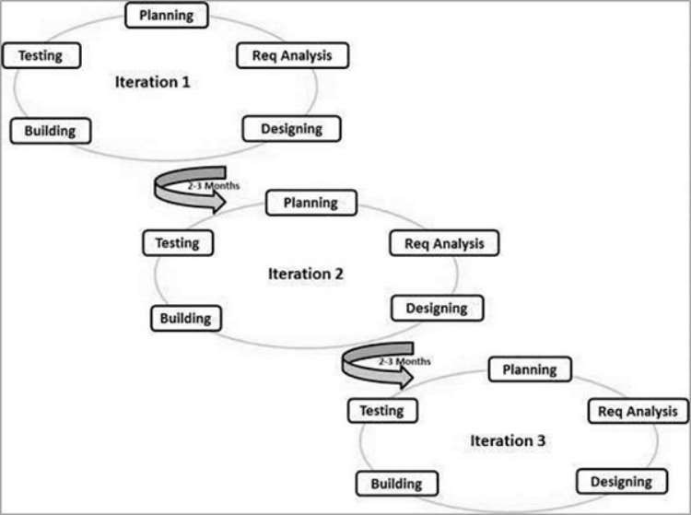

Figure 1 Agile model

Agile methods break the product into small incremental builds. These builds are provided in iterations. Each iteration typically lasts from about one to three weeks. Every iteration involves cross functional teams working simultaneously on various areas like:

1. Planning

2. Requirements Analysis

3. Design

4. Building

5. Unit Testing

6. Acceptance Testing

At the end of the iteration, a working product is displayed to the customer and important stakeholders.

# CHAPTER 2: BACKGROUND STUDY AND LITERATURE REVIEW

## 2.1 Background Study

In recent years, a trend has been observed in the search for a skincare routine with products of natural origin and without chemical or synthetic ingredients, boosting sales of products belonging to this market niche.1 The report “Global Natural and Organic Personal Care Products Industry”, from Ecovia Intelligence (a company specialized in the research, consulting, and training focused on ethical products), projects global sales of natural and organic personal care products at US$ 12 billion between 2021 and 2026. China represents the largest market in this segment in Asia, while in Germany, in Europe, these products already represent 10% of the market.

The term clean beauty emerged in the 1970s as a reference to clean, makeup-free skin. In the 2000s, the word got a new meaning with the launch of skincare lines products that do not contain ingredients with uncertain long-term impact on human health – whether by ingestion, application, cross-contamination, or because it is a potential environmental pollutant after its disposal. It impacts the entire production chain since, from the raw materials used to the production, distribution, sale, and disposal of waste, they must be within the “clean” concept. These choices can benefit the user’s health and the environment but do not necessarily mean a “cleaner” or even safer product, as natural products can also cause contact dermatitis or even photo-dermatitis.

## 2.2 LITERATURE REVIEW

**Natural, organic and vegan**

So far, there is no official regulation in Brazil distinguishing natural products from organic or vegan ones. Thus, the identification of these products is currently made by the presence of seals from certification bodies, such as COSMOS, ECOCERT, Brazilian Vegan Seal (Selo Vegano Brasileiro - SBV), and Bio-dynamic Institute for Rural Development (Instituto Biodinâmico de Desenvolvimento Rural - IBD).

natural cosmetic does not have chemical or synthetic additives in its composition. Raw materials of animal, vegetable, or mineral origins are used to manufacture it, excluding products such as petrolatum and silicones or preservatives, dyes, and fragrances of synthetic origin, for example. In addition to its composition, the product packaging must be designed within this concept, using recyclable, biodegradable, or reusable materials. It is a concept that aims to preserve the environment through the use of raw materials that cause less impact on ecosystems and human health. Although certification bodies cover the presence of a certain amount of organic raw materials in natural formulations, they also allow small amounts of synthetic products, which may vary according to the agency (in general, it is required that 95% of the raw materials used are of natural origin; the other 5% of the composition may contain synthetic substances, provided they are released).

Organic products

The cultivation and use of organic products relate to the attempt to reduce the negative impacts of agriculture on the environment and human health.4,5 The manufacture of organic cosmetics comprises sustainable raw materials with minimal impact on ecosystems, animals, and humans. Pesticides and synthetic fertilizers are prohibited in the cultivation of raw materials. Organic cultivation is based on crop rotation, cover crops, and appropriate choice of species for crop rotation, in addition to biological and natural pesticides. It has a positive impact on reducing greenhouse gas emissions, improving biodiversity, reducing water consumption, and improving soil, water, and air quality.4

For most organic cosmetics certification bodies, at least 95% of raw materials must be of organic origin, and the product must not contain raw materials of synthetic origin to receive organic certification.

Vegan products

Veganism is a philosophy that aims to abolish the use and exploitation of animals for any human activity, mainly motivated by the increase in health and ethics.6 Vegan cosmetics do not use ingredients of animal origin, such as beeswax or lanolin. Also, they have a cruelty-free philosophy, prohibiting products from having their efficacy or safety tested on animals.

Natural product

It is noteworthy that a vegan cosmetic does not have the same definition as a natural or organic one, although they are concepts that can work together. If a cosmetic has 100% synthetic ingredients, it is vegan, as there are no ingredients of animal origin in its formulation. However, it is not considered natural or organic.

Renewable sources x biodegradable product

Terms such as “produced with raw material from a renewable source” or “produced with biodegradable raw material” are widely applied to packaging as a marketing appeal. However, these concepts are often confusing to those who buy the product.

The concept of a renewable source is related to the time and possibility of renewing this material. As with renewable energies, renewable raw materials have a renewal cycle on a human time scale, that is, they are always available and do not run out. Examples of renewable raw materials are those derived from agricultural plants, such as corn, soybeans, or cassava, unlike those derived from petroleum, which is non-renewable. However, not all plant sources are renewable. The plant’s growth time and how extractive is conducted can make it a non-renewable source since the consumption of the product becomes higher than the amount produced. An example is the exaggerated extraction of jacaranda (Pilocarpus microphyllus) in the state of Maranhão, in northeastern Brazil.

Mainly for pilocarpine extraction, the use of the plant is leading to the depletion and threat of extinction of the natural populations of this plant resource.

# CHAPTER 3: SYSTEM ANALYSIS AND DESIGN

## 3.1 Requirement and Analysis

The requirement of this project is given below:

### 3.1.1 Functional Requirements:

Functional requirements define what a produce must do, what it’s features and functions are:

User Registration and Authentication: It allows guides to log in securely.

Profile Management: Allow customer to create and manage their profiles.

User rating review: Enables customers to rate and leave reviews pf the products

Payment Integration: It includes a payment gateway for customer to pay for the product.

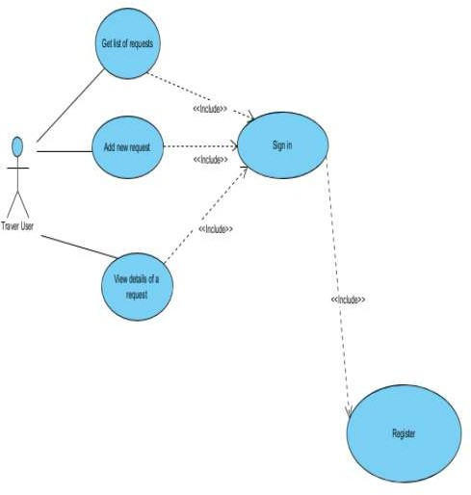

Figure 2: Use case diagram

# 3.1.2 Nonfunctional requirements:

It describe the general properties of a system. Some nonfunctional requirements of this app are:

Usability and user experience: The app will be simple and friendly for customers to use, making it easy for them to search and find what they need.

Performance: The app will open fast and react quickly performs. When customers selects product, send messages, or look up info, the app will respond without making them wait too long.

Security: This app will keep personal info and messages safe by using strong

security when they log in and when data is sent.

Reliability and availability: This app will work whenever users want to use it, so they can access it easily.

### 3.1.3. Hardware Requirements

Processor: Android-10 or higher

Network: Bandwidth greater than 1 MBPS (1000 kbps)

### 3.1.4 Software Requirements

IOS

Android

Feasibility Analysis

Feasibility analysis for a Beauty product app involve assessing whether the app is practical and achievable. It considers technical, operational and schedule feasibility. Here’s a simple breakdown:

All the tools, systems, modules, and libraries required to construct the system are open source, freely accessible, and user-friendly. Consequently, I concluded that the project is technically viable.

Technical Feasibility

This include the study of function. Performance and constraints that may affect the ability to achieve an acceptance system. In this project, I implemented the system as a web-based application. I choose JavaScript as the primary programming language. My selection was based on both the languages ease of use and my familiarity with it.

All the tools, systems, modules, and libraries required to construct the system are open source, freely accessible, and user-friendly.

Operational Feasibility

This evaluates whether the project can be smoothly integrated into the existing operations of an organization. It considers factors such as resource availability, staff capabilities, and workflow adjustments. As far our study is concerned the client are comfortable and happy as the system has cut down their loads and doing. The system's well-structured design will ensure efficient utilization of computer resources, including storage, memory, and processing power. It will feature a user- friendly interface, enabling even non-technical users to operate it easily.

Economic Feasibility

I primarily used a personal computer, personal mobile device, and a personal internet subscription for the majority of the project. This makes the system highly economically feasible, as it doesn't necessitate a substantial budget to create the entire system. Since it doesn't involve a large database, and the data doesn't need to be stored permanently, maintenance is relatively straightforward, and the associated costs are not excessive.

Resources Feasibility

Resource feasibility evaluates the availability of essential resources like personnel, equipment, and materials needed for the project. This process is a crucial step in project management and decision- making, helping organizations and individuals make informed choices about whether to proceed with a particular endeavour.

Schedule Feasibility

The Schedule Feasibility analysis employed the Critical Path Method(CPM). This method enabile the identification of critical task and the determination of interrelationships among these tasks. CPM aided in planning by distinguishing between critical and non-critical tasks, ultimately aiming to mitigating timing issues and potential process bottlenecks.

# 3.2 Gantt Chart

Figure Gantt chart

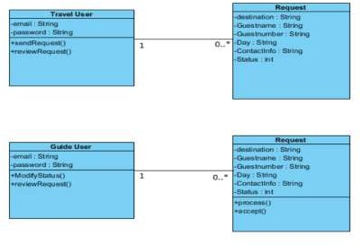

Figure 4 Class Diagram

**Sequence Diagram**

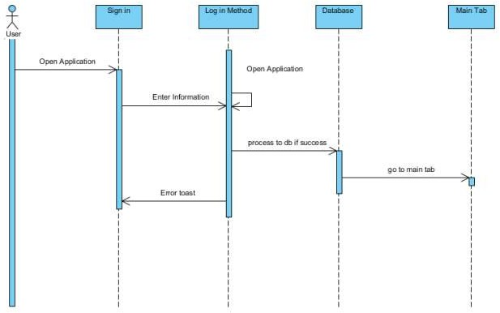

Figure 5 User Log in Sequence Diagram

First the user will fill in all the details of the fields as well as allowing the location service. If the data that user input is valid, it will be inserted to the database, otherwise the user will get an error alert to let that user know that the value is invalid**.**

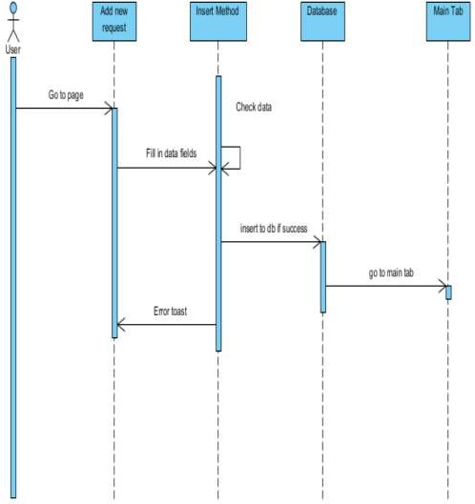

Figure User Insert Sequence Diagram

As shown in Figure 6, the person will be able to check all the details of requests, which include Buying request and Processing request. For the buying request, the user can mark as Processing by clicking on the Buy Now button and calling the Process method.

**Activity Diagram**

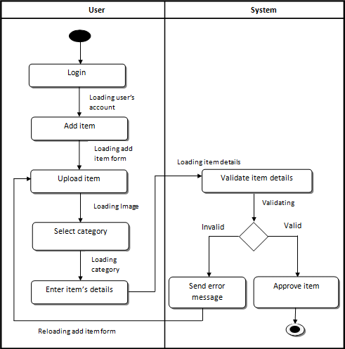

Figure Activity diagram

# CHAPTER 4: SYSTEM IMPLEMENTATION

## 4.1 Implementation

**CASE Tools:** Utilized 'Draw.io' as a Computer-Aided Software Engineering (CASE) tool for creating visual diagrams and architectural representations. This tool facilitated clear communication and visualization of the project's structure.

**Programming Languages**: The project primarily employed Flutter, a framework that uses Dart as its programming language. Dart was chosen for its performance and compatibility with the Flutter framework.

Development Environments: The development process was carried out using two integrated development environments (IDEs). 'Visual Studio Code' provided a versatile coding and debugging environment, while 'Android Studio' offered robust support for Android app development.

**Database Platform:** Firebase was chosen as the database platform for the project. Specifically, we used 'Firebase Firestore,' a NoSQL database, for its scalability and real-time database capabilities.

**Testing**

System testing comprises a series of distinct tests, each serving the overarching purpose of thoroughly assessing the computer-based system. While these tests have varying objectives, collectively, they aim to verify the proper integration of all system components and their successful execution of allocated functions. The testing process is undertaken to ensure that the product precisely fulfills its intended purpose

**Unit Testing**

Unit testing represents the initial level of testing, often carried out by the developers themselves. Its purpose is to ensure that individual components of software, at the code level, function correctly and according to their intended design. In a test-driven development environment, developers typically create and execute these tests before passing the software or feature to the testing team. While unit testing can be performed manually, automating this process accelerates delivery cycles and broadens test coverage. Additionally, unit testing simplifies debugging, as identifying issues early allows for quicker resolution compared to discovering them later in the testing phase. Debugging tasks are much easier because they only affect one unit and must be done on that unit if a flaw is found.

**Integrated Testing**

Integrated Testing is testing in which a group of components are combined to produced to produce output. Also, the interaction between software and hardware is tested in integration testing if software and hardware components have any relation. The primary goal of integration testing is to ensure that these individual units, which may work perfectly on their own (as confirmed through unit testing), function correctly when combined together in the integrated system.

Table 1: Test Case for Login

|  |  |  |  |  |
| --- | --- | --- | --- | --- |
| **SN** | **Test Case** | **Expected Outcome** | **Actual**  **Outcome** | **Remarks** |
| **1** | Login with empty  Email | Email Required | Email Required | Pass |
| **2** | Log in with  empty password | Password is required. | Password is required. | Pass |
| **3** | Log in with  invalid email and password | Invalid credentials. | Invalid credentials. | Pass |
| **4** | Log in with valid email and  Password | You are logged in successfully. | You are logged in successfully. | Pass |

# CHAPTER 5: CONCLUSION AND FUTURE RECOMMENDATION

## 5.1 Conclusion

In conclusion, the skincare product industry stands as a thriving and continuously evolving sector, driven by a confluence of factors. With consumers increasingly prioritizing skincare as an essential component of their daily routines, the market has witnessed remarkable growth and diversification. The industry's scope extends far and wide, offering a vast array of products designed to cater to various skin types, concerns, and preferences. From anti-aging solutions and natural formulations to personalized regimens and sustainable practices, skincare brands are innovating to meet the ever-expanding demands of a discerning and wellness-conscious clientele. Furthermore, the influence of e-commerce, digital education, and the burgeoning men's skincare market contribute to the industry's global reach and transformative potential. As consumers continue to seek effective, safe, and sustainable solutions for healthier, more radiant skin, the skincare product industry remains a vibrant and essential component of the beauty and wellness landscape.

Currently, consumers are increasingly aware of the composition of products consumed in their daily lives. This concern about knowing the composition before purchase is quite consolidated in food, but has been migrating to cosmetics. The main positive point is that clean beauty has been encouraging both the cosmetic and raw material industries to conduct better safety studies of actives and better select the products and packaging used in production. Another essential point is that consumers of clean beauty products demand transparency from manufacturers. It has caused a movement in the global cosmetics market towards more open communication about product components and their impact on the skin and the environment.

As there is no regulation or legal or official definition, each product brand defines clean beauty according to the company’s internal policy and marketing. It brings heterogeneity of raw materials and products that may not match the proposal to be a product free of toxic ingredients.

## **5.2 Recommendation:**

Recommender systems have seen continuous development over the years, with occasional periods of slower progress. In recent years, advancements in machine learning, large-scale networks , and high-performance computing have reignited interest in this field. In our future work, we will focus on the following aspects:

**Consult a Dermatologist:** Before starting any new skincare regimen or using specialized products, it’s advisable to consult a dermatologist. A professional assessment can help identify your skin type, concerns, and any underlying conditions, allowing for personalized recommendations.

**Sunscreen Daily:** Make daily sun protection a non-negotiable part of your skincare routine. Use a broad-spectrum sunscreen with SPF 30 or higher, and reapply as needed, especially when outdoors.

**Patch Testing:** When introducing new skincare products, perform a patch test on a small area of your skin to check for potential allergies or adverse reactions.

**Read Labels:** Familiarize yourself with the ingredients in your skincare products. Look for products with ingredients that address your specific skin concerns and avoid those that may trigger sensitivities.

**Hydration:** Stay well-hydrated by drinking plenty of water. Hydration is essential for overall skin health.

**Gentle Cleansing:** Avoid harsh cleansers that can strip the skin of its natural oils. Opt for gentle cleansers suitable for your skin type.

# REFERENCES:

RB Khaire, P Suryawanshi, A Kadtan, J Dayalani.(2021)”Beauty Parlour Management System”( 2021).International Journal of Scientific Research & Engineering Trends.

Adarsh Kumar Gulshan, Amir Khan,(2021) “Salon Management System”. 2021 International Journal of Creative Research Thoughts (IJCRT)

V, A., S, A. K., RM, A., & S, G. (2019). “BOOKAZOR - an Online Appointment Booking System”. 2019 International Conference on Vision Towards Emerging Trends in Communication and Networking (ViTECoN). doi:10.1109/vitecon.2019.

Reganold JP, Wachter JM. Organic agriculture in the twenty-first century. Nat Plants. 2016;2:15221.

Mathieu S, Dorard G. [Vegetarianism and veganism lifestyle: Motivation and psychological dimensions associated with selective diet]. Presse Med. 2016;45(9):726-33.

Pinheiro CUB. Extrativismo, cultivo e privatização do jaborandi (Pilocarpus microphyllus Stapf ex Holm.; Rutaceae) no Maranhão. Acta Bot Bras. 2002;16(2):141-50.

Haider TP, Volker C, Kramm J, Landfester K, Wurm FR. Plastics of the future? The impact of biodegradable polymers on the environment and on society. Angew Chem Int Ed Engl. 2019;58(1):50-62.

Sun Q, Ren SY, Ni HG. Incidence of microplastics in personal care products: an appreciable part of plastic pollution. Sci Total Environ. 2020;742:140218.

# BIBLIOGRAPHY

React + Django Integration:

Django REST framework - For building APIs in Django.

How to Integrate React with Django - DigitalOcean tutorial.

React and Django Integration Guide - by William S. Vincent.

# **Reference**

Tutorials Point (2019). SDLC Waterfall Model. [Online] www.tutorialspoint.com.

Available at: https://www.tutorialspoint.com/sdlc/sdlc_waterfall_model.htm.

Zhai, Y. and Lu, W. (2017). The Online Bookstore. MATEC Web of Conferences, 100,

p.02045. doi:10.1051/matecconf/201710002045.

Lewis, S. (2019). What is waterfall model? - Definition from WhatIs.com. [online]

SearchSoftwareQuality. Available at:

https://www.techtarget.com/searchsoftwarequality/definition/waterfall-model.

ss

citethisforme.com/cite/website/autocite

**ANNEX:**

**Homepage**

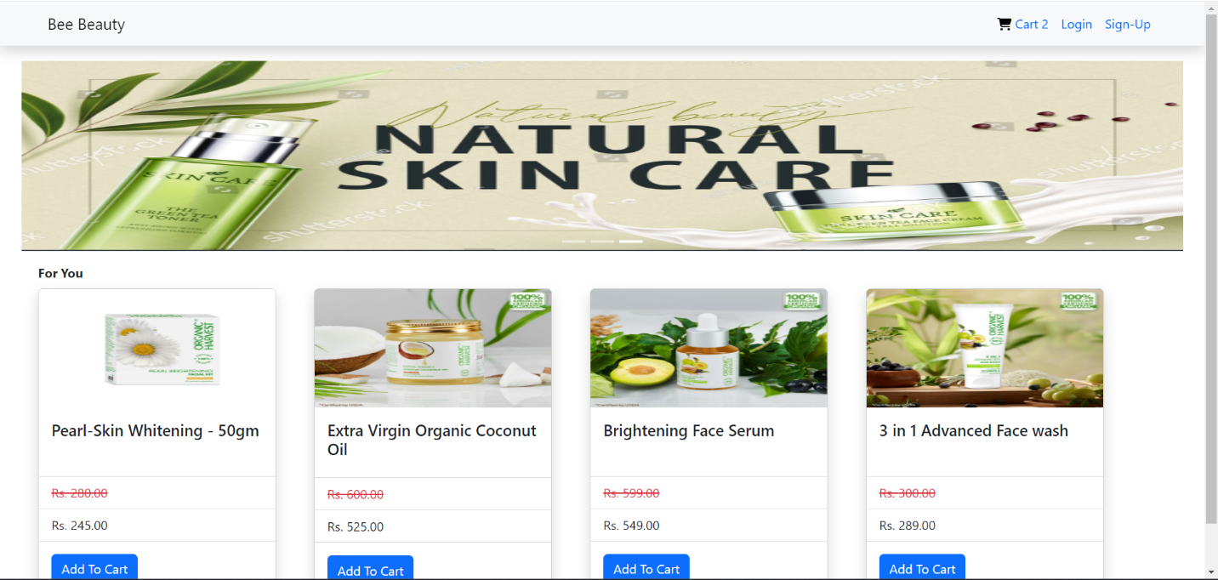

**Cart**

**User Registration**

**Login**

**Add Product**

